Lab 3: HTML Basics — Structure & Semantic Markup

Step-by-Step Breakdown

🔧 1. Setup Your Environment
- Install Tools:
  - VS Code
  - Live Server Extension
  - W3C HTML Validator
- Create Project Folder:
  - Name it something like lab3-html-basics
  - Inside, create index.html

2. Build Semantic Structure in index.html
Use semantic HTML5 tags to organize your page:
<!DOCTYPE html>
<html lang="en">
<head>
<meta charset="UTF-8">
<meta name="viewport" content="width=device-width, initial-scale=1.0">
<title>My Personal Webpage</title>
</head>
<body>

<header>
<h1>Welcome to My Webpage</h1>
<p>Short intro or tagline</p>
</header>

<nav>
<ul>
<li><a href="#about">About Me</a></li>
<li><a href="#projects">Projects</a></li>
<li><a href="https://github.com/">GitHub</a></li>
</ul>
</nav>

<main>
<article id="about">
<h2>About Me</h2>
<p>Brief bio or description</p>
<img src="profile.jpg" alt="My profile picture">
</article>

<aside>
<h3>Quick Facts</h3>
<ul>
<li>Location: Punjab, Pakistan</li>
<li>Interests: Web Development, AI</li>
<li>Languages: English, Urdu</li>
</ul>
</aside>

<article id="projects">
<h2>Projects</h2>
<ul>
<li><a href="project1.html">Project 1</a></li>
<li><a href="project2.html">Project 2</a></li>
</ul>
</article>
</main>

<footer>
<p>© 2025 Muhammad. All rights reserved.</p>
<p><a href="mailto:muhammad@example.com">Contact Me</a></p>
</footer>

</body>
</html>

3. Add Content Elements
- Images: Use .jpg, .png, or .svg with descriptive alt attributes.
- Lists: Use <ul> or <ol> for facts, links, or features.
- Links:
  - Internal: href="#section-id"
  - External: href="https://..." with target="_blank" if needed.

4. Accessibility Basics
- Use meaningful alt text for all images.
- Ensure link text is descriptive (avoid "click here").
- Use proper heading hierarchy (<h1> to <h3>).
- Label navigation clearly.

5. Validate HTML
- Go to W3C Validator
- Upload or paste your HTML code.
- Fix any warnings or errors (e.g., missing alt, unclosed tags).

6. Final Deliverables
Requirement | Description
✅ Semantic Usage (4) | Use of header, nav, main, article, aside, footer
✅ Accessibility (3) | Alt text for images, clear labels, heading structure
✅ Validation (3) | Pass W3C validation with no errors or warnings
✅ Hosting | Push to GitHub repo or local server using Live Server
✅ Report | Save validation screenshot or summary in repo (e.g., validation.txt)

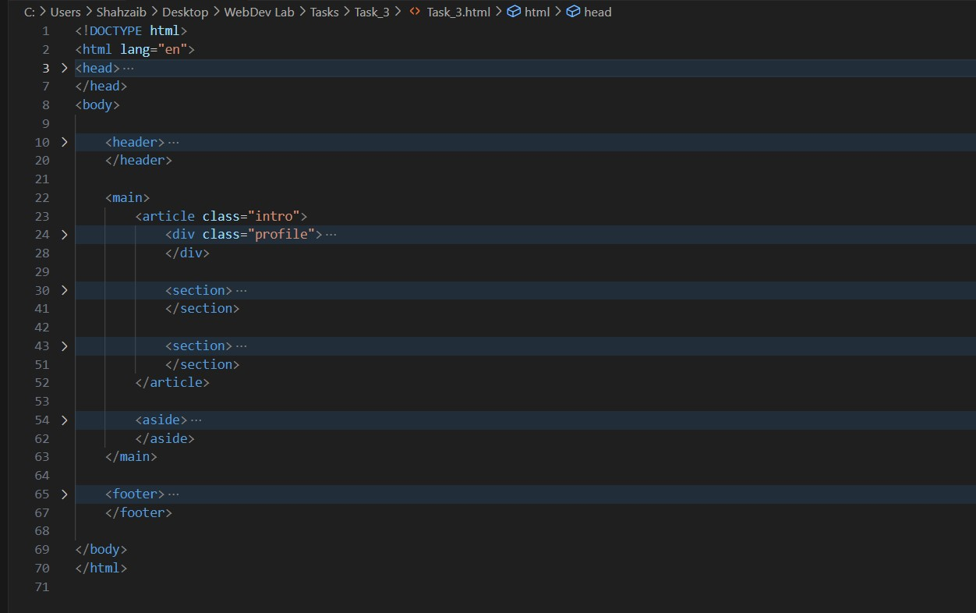

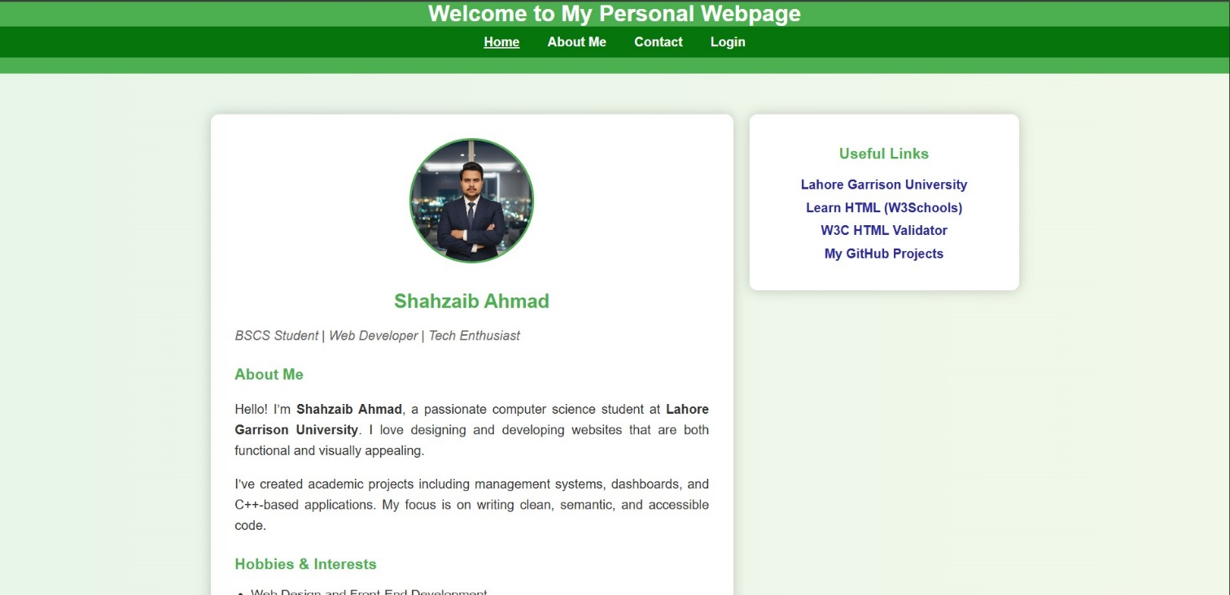

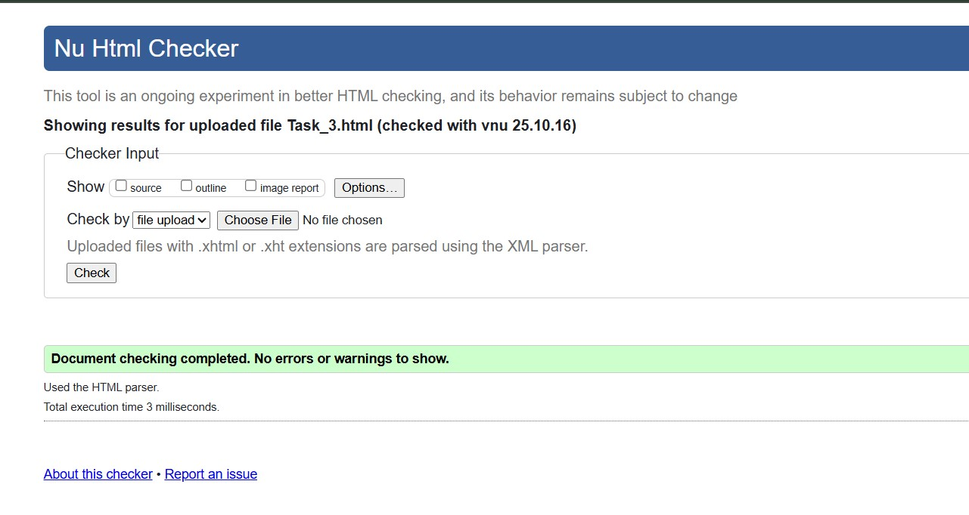

CONCLUSION:

In this lab, I learned how to create a simple and well-structured webpage using HTML5 tags. I used elements like header, nav, main, article, aside, and footer to organize the page. I also learned to add images, links, and lists correctly and to make the page accessible and error-free using the W3C Validator.

RUBRICS:

Performance |  |  | Lab Report
Description | Total Marks | Marks Obtained | Description | Total Marks | Marks  Obtained
Ability to Conduct practical | 5 |  | Structure | 5
Data Analysis & Interpretation | 5 |  | Efficiency | 5
Total Marks obtained |  |  | Total Marks Obtained

Instructor Signature

